 | Item Required | Grade 1/2 | Grade 3/4 | Grade 5/6 | Grade 7/8
 | 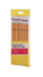  Pencils  (Quality brand, please sharpen) | 30 | 30 | 10 | 10
 | 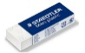  Eraser  (white vinyl) | 4 | 4 | 2 | 2
 | 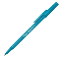  Blue Pens | 0 | 0 | 5 | 5
 | 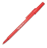  Red Pens | 0 | 2 | 2 | 2
 | Ruler (metric, acrylic) | 1 | 1 | 1 | 1
 | 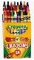  Wax Crayons (Crayola – 24) | 1 | 1 | 0 | 0
 | 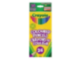  Pencil Crayons  (24 sharpened) | 1 | 1 | 1 | 1
 | 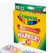  Felt Markers  (thick, washable) | 1 | 1 | 1 | 1
 | 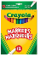  Felt Markers  (thin, washable) | 0 | 0 | 1 | 1
 | 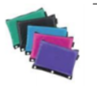  Pencil Case  (cloth, zipper) | 2 | 1 | 1 | 1
 | 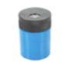  Pencil Sharpener | 1 | 1 | 1 | 1
 | 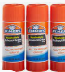  Glue Stick | 8 | 4 | 4 | 4
 | 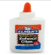  White glue | 1 | 1 | 0 | 0
 | 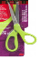  Scissors | 1 | 1 | 1 | 1
 | 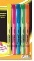  Highlighters  (set of multicolors) | 1 | 1 | 0 | 1
 | 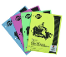  Notebooks  (no coil) | 4 | 4 | 0 | 0
 | Paper Report Covers (Duotangs)  1 each (Red, Yellow, Orange, Light Blue, Dark Blue, Green, Black) | 7 | 7 | 7 | 0
 | 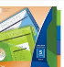  Page Dividers | 0 | 0 | 0 | 1
 | 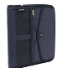  Binder 2”  (with zipper) | 0 | 0 | 0 | 1
 | 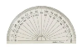  Protractor | 0 | 0 | 1 | 1
 | 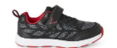  Indoor runners | 1 | 1 | 1 | 1
 | 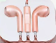  Computer headphones/earbuds | 1 | 1 | 1 | 1
 | 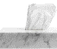  Kleenex | 1 | 1 | 1 | 1
 | Phys. Ed. Class (does not need to be new)  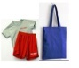  1 Pair of shorts  1 T-shirt  1 Bag | 0 | 0 | 1 | 1

