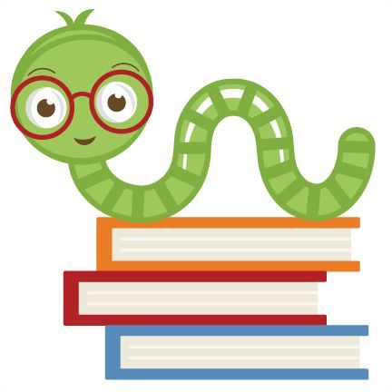
Holy Rosary Community School Library & Procedures

2020/2021
Teacher Librarian: Ms. A Osiowy

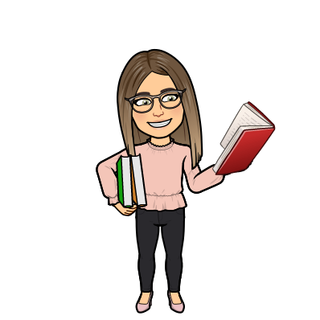
Welcome to the library handbook. This booklet will share all of the procedures, rules and protocols that will ensure the library is efficient and runs smoothly. If you have any questions, I am always willing to answer them!
Library Rules
- Always use an indoor quiet voice when in the library
- Please respect and treat all library materials with care
- Be patient and kind
- Keep others personal space in mind when looking at books to choose
- It is important to choose a “just right” book
- If you touch a book, please give it to your teacher or place it into the “book quarantine” bin to be cleaned.
Visiting the Library
For the first part of the year, we will not be using the library for work periods or book exchange. This may change as the school year moves forward. Teachers are welcome to access the library materials at any time, but please remember to check out the books that you are taking if I am not there to help you.
I am hoping students will be able to choose their own books soon, as it is much more engaging and motivating for them to do it on their own.
Students will have the opportunity to visit the library with their class on their assigned day and time of the week, as monitored by their teacher. Students will also have the opportunity to visit the library during open library times.
- Open book exchange: 9:15-9:45 (Day 1-4)
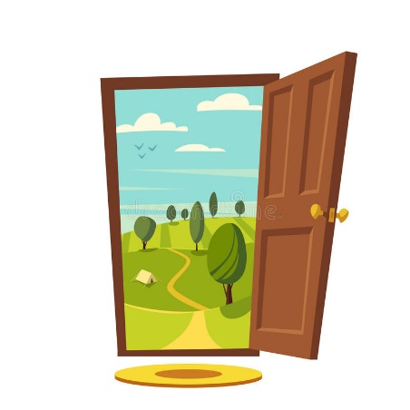
Open Library Time Procedures
- Open library time will be closed for the month of September. This will be re-assessed in October.
- During open library time Ms. Osiowy will be in the library to assist students with checking out their books.
- Please only send a 2-4 students at a time so that we have the space to social distance if needed. This will also reduce traffic and noise within the library. Open library time may be placed into time blocks if needed as well.
- Students are encouraged to only touch books that they are wanting to read. A good practice is to just look at books on the table until they see a book that interests them.
- Once students find a book that they are interested in reading, they are to wait in line to sign it out and promptly head back to class.
- If behavior becomes a reoccurring problem, the student will be given a warning and will be unable to participate in open book exchange.
Caring for Books/Resources
- Always use a bookmark when reading (See Ms. Osiowy for some fancy ones)
- Don’t bend the pages or the cover of the book
- If there is a damaged book, please bring it to Ms. Osiowy ASAP or place it on the desk with a note
- Hold books gently and do not swing them by the cover
Library Cards
- All students will be given their own library card with their name and barcode on it
- The teacher can decide how they keep track of their classes library card. Keeping it in front of agenda or on library sticks is a great option.
- There will be a back-up set of library cards for each class in the little card holders on the wall behind the library desk. Please return the cards after use
- If a student requires a replacement card, please let Ms. Osiowy know ASAP

Checking Out Books
- Students are able to check out/choose 2 books at a time
- Reminder to look for “just right” books when helping students choose books
- If a student has outstanding books out, they are to only exchange books for which they returned
- Please make sure every book is signed out using the computer
- For the month of September, the primary grades Pre-K to ¾ Will be given a bin filled with a variety of books by myself. The teacher will have to sign out these books to each student using a portable scanner (info to come).
- The older grades will be encouraged to go online to destiny and search for books they are interested in. Teachers will be given a request form to fill out/students will fill out their own and send it to the TL.
- See form for info: New Email address
- Option is open to receiving a book bin as well
- Link: https://form.jotform.com/202445421613243

Returning Books

- Place returned books in the slot on the library desk
- Students will not be able to take out a book that another classmate has just returned, as the books need to be cleaned
- Place any large books on the desk
- For the month of September, please do not place books in the slot. Books will be returned into the specific bin on which day it was returned (Mon-Fri). These books will have to sit for at least 72 hours before they can be returned into the system and placed back onto the shelves.
Overdue books
- Students will be able to keep a book for 1-2 weeks depending on their library time
- Students are able to renew the book up to 2 times if they are still reading it
- I will provide classroom teachers with an updated report of overdue books at the end of each month
Misplaced Books & Resources
- In the event that a book has been lost or not returned, the student will receive a reminder to look for the book at home or at school.
- The student may receive a letter to go home reminding the parents to look as well.
- Students will be encouraged to return the lost materials, and if not, may be responsible for the replacement costs.
- Reminders and emails will be completed as needed
Textbooks
- Classroom teachers will be given their textbooks at the beginning of Sept.
- Textbooks will be signed out to the classroom teacher
- Teachers are encouraged to keep a detailed list of the textbook number/student receiving the textbook
- Due to COVID, students are not permitted to share textbooks (use Pearson online if needed)
- Please be mindful of sending textbooks home. Utilize online resources when possible
- If you require any additional textbooks, please see the principal.

If you ever have any questions, feel free to ask or send me an email and I would be delighted to help you!
Contact Info:
Ms. Ashley Osiowy
Holy Rosary Community School
Email: a.osiowy@rcsd.ca

